3.77: a) The path is a cycloid.
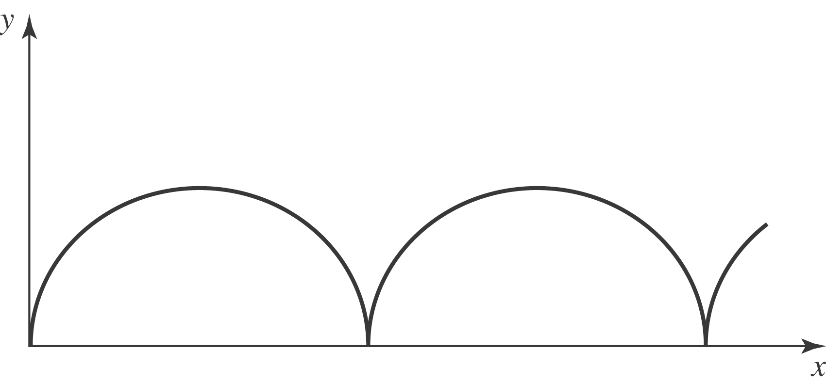

b) To find the velocity components, take the derivative of x and y with respect to time: 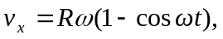 and 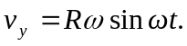 To find the acceleration components, take the derivative of 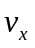 and 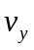 with respect to time: 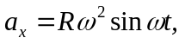 and 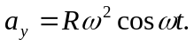
c) The particle is at rest 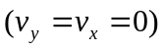 every period, namely at 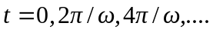 At that time, 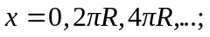 and 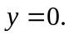 The acceleration is 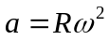 in the 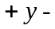direction.
d) No, since 